Practical No: 03

**Aim:** Raspberry Pi Based Oscilloscope.

**Hardware Required:**

1. Raspberry Pi 3B+
2. Ethernet Cable
3. Monitor
4. HDMI to VGI convertor
5. Micro SD card (any class best is class 10)
6. Adaptor with 5v 2A
7. USB mouse
8. USB keyboard
9. Female – Female jumper wires. (5 numbers)
10. ADS1115

**Software Required:**

1. Raspbian OS
2. Node-Red

**Procedure:**

1. **Hardware Setup:**

* Connect the pins as given bellow….
* **Pi 3V** to **ADS1015 VDD** - Remember the maximum input voltage to any ADC channel cannot exceed this VDD 3V value!
* **Pi GND** to **ADS1015 GND**
* **Pi SCL** to **ADS1015 SCL**
* **Pi SDA** to **ADS1015 SDA**

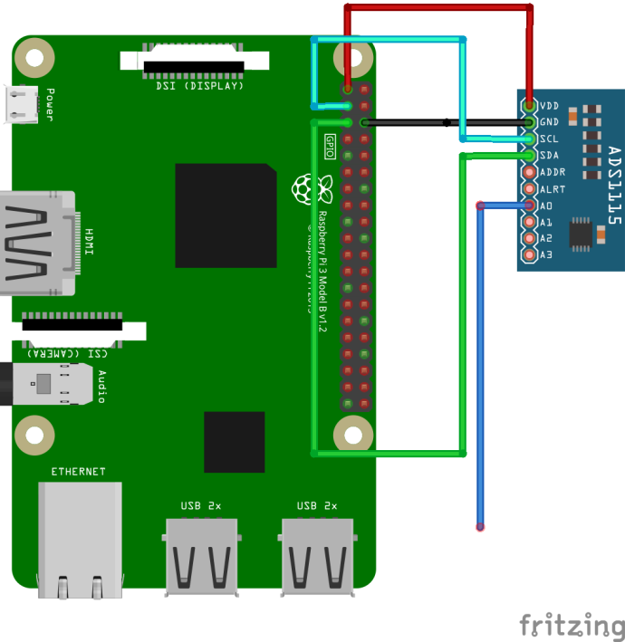

1. **Software Setup:**

* Type the Following in the Terminal
* *sudo apt install npm*
* *node-red-start*
* Navigate to Start 🡺Preferences 🡺Raspberry Pi Configuration 🡺Interfaces

Enable I2C and click on OK.

* Open the browser and navigate to <http://localhost:1880>.
* Option 🡺 Manage Palette 🡺 Install (search for “node-red-contrib-ads1x15”)

Install it.

* Drag and drop the following elements ….



* Connect as shown in the below figure…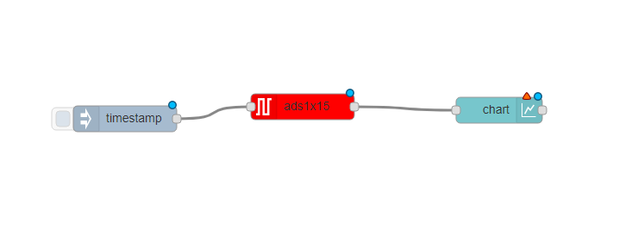
* Double click on charts and create a new group by clicking on the pencil icon on the right.
* Change the “Default” to Home or any name you want.
* Click on the pencil icon on the right and click add
* Double click on “timestamp” element and change none to interval of 1 second
* Double Click on “chart” and change interpolate to “bezier” and x-axis to 1 minute.
* Navigate to <http://localhost:1880/ui> to see the oscilloscope reading touch the **A0** pin with your hand to change the potential difference as a result of which changing the reading on the screen.

**Precautions:**

* If it is a fresh flash of Raspbian OS “*sudo apt update”* and “*sudo apt upgrade”* is a must thing.
* Connect the components before powering on the device and double check your connections.

